# What are the different margins options and do we adjust the margins of the excel worksheet?

Unlike Word, Excel has only two sets of built-in margin styles in addition to the default or normal style. Thus, we can select these existing margins with just a few clicks. Before we move on to the process of adjusting the margin, let us learn about the margin options available in Excel. They are as follows:

**Normal**: The normal margin setup is the default margin that Excel follows for each Excel sheet and its pages. It uses the standard top, bottom, left, and right margins of 3/4 inch, where 1/4 inch separates the header and footer from the top and bottom margins, respectively. Despite the default margin, Excel allows us to choose from two other margin settings, namely Wide and Narrow.

**Wide**: The Wide margin settings that Excel applies to selected sheet uses the standard top, bottom, left, and right margins of 1- inch, where 1/2 inch separates the header and footer from the top and bottom margins, respectively.

**Narrow**: The Narrow margin settings that Excel applies to the selected sheet uses the standard top and bottom margins of 3/4 inch, left and right margins of 1/4 inch, where 0.3 inch separates the header and footer from the top and bottom margins, respectively.

**Custom**: We can use our custom margins if we don't like the default margins and other built-in sets of margins. Using Custom Margins in Excel, we can specify desired margins for headers and footers and centre the content of our sheets vertically and horizontally. Custom margin adjustments help us to improve the appearance of the worksheet to our liking.

Yes, we adjust the margins of the excel worksheet.

1. **Set a background for wer table created.**

**Answer:-**

* 1. Click the worksheet that we want to display with a sheet background. Make sure that only one worksheet is selected.
  2. On the **Page Lawet** tab, in the **Page Setup** group, click **Background**.

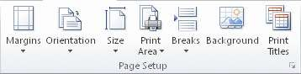

* 1. Select the picture that we want to use for the sheet background, and then click **Insert**. The selected picture is repeated to fill the sheet.
     + To improve readability, we can hide cell gridlines and apply solid colour shading to cells that contain data

A sheet background is saved with the worksheet data when we save the workbook.

1. **What is freeze panes and why do we use freeze panes? Give examples.**

**Answer:-** To keep an area of a worksheet visible while we scroll to another area of the worksheet,

go to the **View** tab, where we can **Freeze Panes** to lock specific rows and columns in place, or we can **Split** panes to create separate windows of the same worksheet.

Freeze rows or columns

# Freeze the first column

* Select **View** > **Freeze Panes** > **Freeze First Column**.

The faint line that appears between Column A and B shows that the first column is frozen.

# Freeze the first two columns

* 1. Select the third column.
  2. Select **View** > **Freeze Panes** > **Freeze Panes.**

# Freeze columns and rows

1. Select the cell below the rows and to the right of the columns we want to keep visible when we scroll.
   * On the **View** tab > **Window** > **Unfreeze Panes**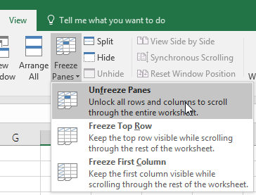
2. **What are the different features available within the Freeze Panes command?**

There are some points that you should be aware with them -

1. Once the worksheet is frozen using the freeze pane feature, you cannot unfreeze the worksheet by undoing the action. You have to unfreeze it manually.
2. If you freeze the top row, only the first row of the sheet will be frozen. You cannot freeze the column at the same time.

***Freeze Panes****:* It freezes the rows as well as the columns.

***Freeze Top Row****:* It freezes all the rows above the active cell.

***Freeze First Column****:* It freezes all the columns to the left of the active cell.

You can use these options to lock rows or columns (or both) into panes in Excel.

1. **Explain what the different sheet options present in excel are and what they do?**

# Sheet Options in Excel

MS Excel or Microsoft Excel is currently the most powerful spreadsheet software developed by Microsoft. It allows us to organize vast amounts of data across multiple sheets. Every Excel workbook has at least one sheet. By default, when we create a new Excel file, it usually has three sheets, namely Sheet1, Sheet2, and Sheet3. Furthermore, we can add or delete the desired number of sheets accordingly.

In this article, we are discussing the various Sheet Options present in Excel. But, before understanding the sheet options, let us first take a brief introduction of the sheet with the help of its definition.

## What is a Sheet in Excel?

An Excel sheet, also called a worksheet, is a single page or a document in an Excel workbook with the collection of cells to help us organize the data. Based on requirements, an Excel workbook can have many sheets. The sheets are typically listed as tabs and are accessed from the bottom of the Excel window.

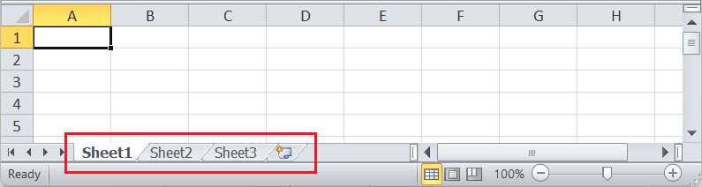

In the above image, the default Excel sheets are present on the Sheet Toolbar. We can switch between the sheets by clicking on the sheet's name that we want to view. Also, there are many things or tasks that we can perform with Excel sheets. All the corresponding features of the sheet are accessed using the **Sheet Options** in Excel.

## What are the sheet options in Excel?

Since an Excel sheet is one of the core elements of the workbook, there are multiple core options to perform from the Sheet Options. We can access various sheet options by using the following ways:

* Ribbon Sheet Options
* Right-click Sheet Options

Let us discuss each in detail:

### Ribbon Sheet Options

Excel has all the basic and advanced options present on its ribbon. Likewise, some quick sheet options are also present on the Excel ribbon and can be accessed by going to **Page Layout > Sheet Options.** It mainly has four toggle options: two for **Gridlines** and two for **Headings,** and they can be turned on and off by selecting and deselecting the checkboxes.

* **Gridlines:**
  + **View:** This option allows users to show/ hide gridlines within the active worksheet. Turning off this option removes the gridlines from the sheet and displays a blank Excel sheet.
  + **Print:** This option allows users to show/ hide gridlines on an Excel document that will be printed on paper.
* **Headings:**
  + **View:** This option allows users to show/ hide headings within the active worksheet. Turning off this option removes the headings from the current sheet's headers and footers.
  + **Print:** This option allows users to show/ hide headings on an Excel document, which is to be printed on paper.

The above sheet options are worksheet-specific, and changes are only applied to the active worksheet. This means that we have to adjust these options again for the new worksheets and workbooks.

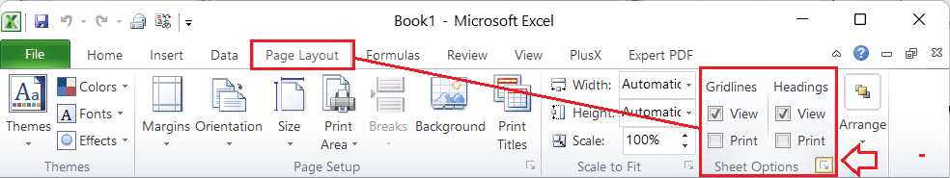

In the above image, we also see the small box with an arrow icon on the corner of the Sheet Options group. It is usually called the 'More' button for accessing advanced options for the corresponding group or category.

### Sheet Options in Dialogue Box under Page Setup

After clicking on the 'More' option (the arrow icon on the corner of the Sheet Options group on the ribbon), we get various sheet options. These sheet options are mainly used to adjust preferences for printing purposes. For instance, when we print Excel documents, gridlines are not usually printed. We can adjust preferences from sheet options to include the gridlines to print and manage other sheet options.

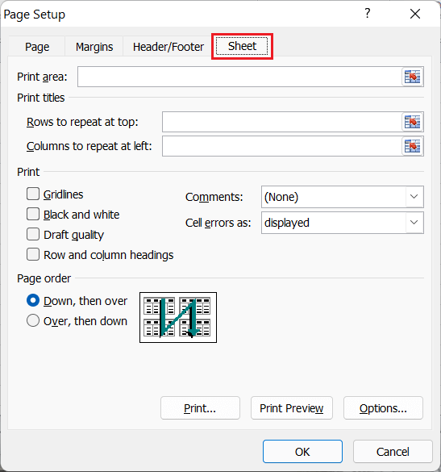

* **Print Area:** We can select the print area using this option. We can drag and select the area or range of cells by using the mouse.
* **Print Titles:**
  + **Rows to repeat at top:** This option helps us select the title to display at the top for corresponding rows.
  + **Columns to repeat at left:** This option helps us select the title to display on the left side for columns.
* **Print:**
  + **Gridlines:** This option can be enabled or disabled by selecting/ deselecting the checkbox. It helps us decide whether to show gridlines or not on printed Excel documents.
  + **Black & White:** Like the gridlines, we can select this checkbox to print the current Excel document in black and white color, even if we have the color printer attached.
  + **Draft Quality:** Selecting the checkbox associated with the draft quality allows us to print the Excel document using the printer's draft-quality settings.
  + **Rows & Column Heading:** We can select this option to display rows and columns headings to the printed Excel documents.
* **Page Order:**
  + **Down, then Over:** This option allows users to print the down page first and then the right pages.
  + **Over, then Down:** This option allows users to print the right pages first and then the down pages.
* **Print:** Clicking on this option gives a command to the device to print the current Excel document using the default printer.
* **Print Preview:** This option displays the preview of the Excel document that will be printed on paper.
* **Options:** This option allows users to choose layout type (portrait or landscape) and paper mode (A4, A5, etc.) for the Excel document to be printed.

### Right-click Sheet Options

In Excel, the right-click with mouse button usually displays the context menu for the selected element. When we press the right-click on any Sheet tabs, Excel displays a list of options relevant to Excel sheets. The list includes various sheet options. However, this list is usually called the 'worksheet menu'.

The right-click sheet options are shown in the following image:

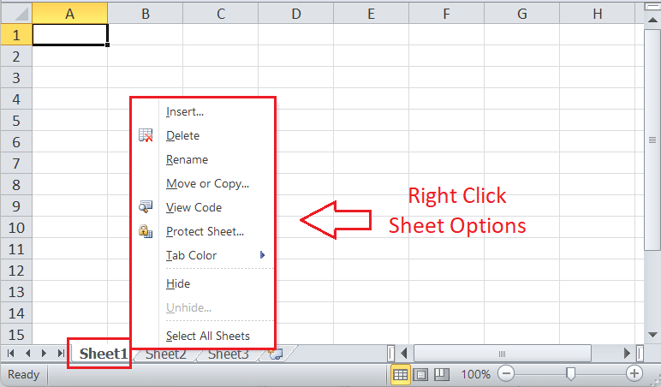

In the above image, we can see various sheet options. Let us understand the use of each option in detail:

### Insert

While working on Excel, we may sometimes need more sheets. For this, we need to go to the Sheet options by right-clicking the worksheet name on the sheet tab, then select Insert from the list. As soon as we click the Insert, the new blank worksheet will appear in the current workbook.

We can also use the **New Sheet button** (Plus button next to sheet tabs) to add a new worksheet instantly.

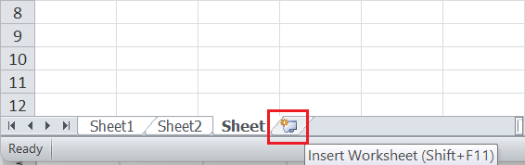

We can also change the default number of worksheets to be added to each new workbook. For this, we need to go to **File > Excel options > General > Include this many sheets.**

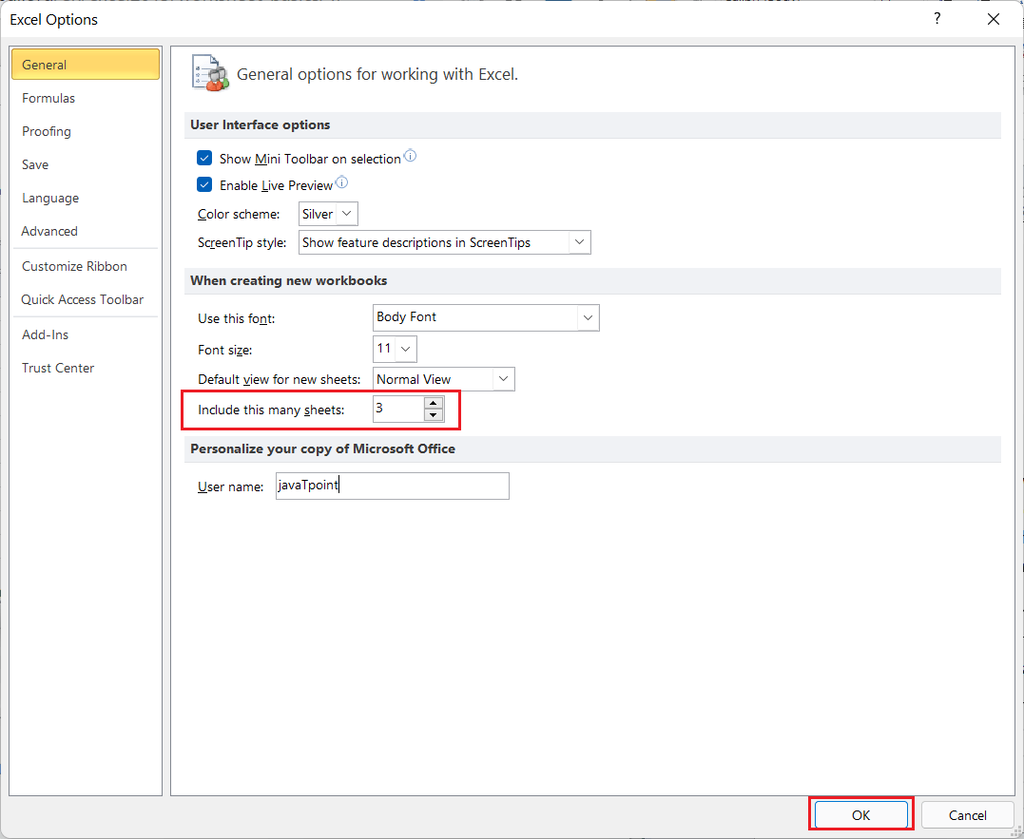

### Delete

Excel also allows us to delete the undesired sheets from the workbooks. For instance, suppose that we only want to organize our data in a single sheet, then deleting the remaining sheets will give a professional and clean look to our workbook.

To delete any desired sheet from the workbook, we must first press the right-click on a specific sheet on the sheet tabs and then select the **Delete** option from the list of sheet options.

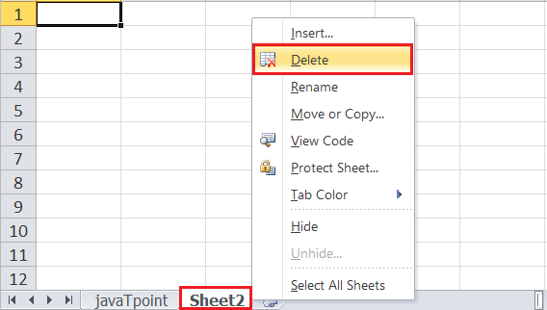

As soon as we click the Delete button, the corresponding sheet is instantly deleted from our workbook.

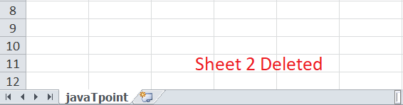

### Rename

Whenever we create a new Excel workbook, we usually get three excel sheets with default names, Sheet1, Sheet2, and Sheet3. Also, if we insert a new sheet, Excel follows the same order and inserts new sheets with names like Sheet4, Sheet5, etc. However, we can rename any worksheet and change the default sheet name to any desired name to better reflect its content.

To rename the worksheet, we can use the **Rename** from the sheet options after right-clicking on the desired sheet name on the sheet tab. After that, we need to enter the desired name for the specific worksheet and click the **Enter** key. The worksheet will be renamed instantly.

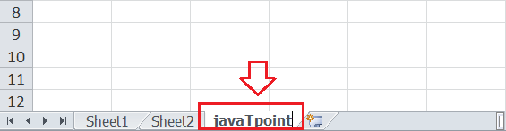

### Move or Copy

When we need to duplicate the data from one sheet to another in Excel, we can use the Move and Copy option from the right-click sheet options list. We must first right-click on the sheet that we wish to copy and then select the **'Move and Copy'** option.

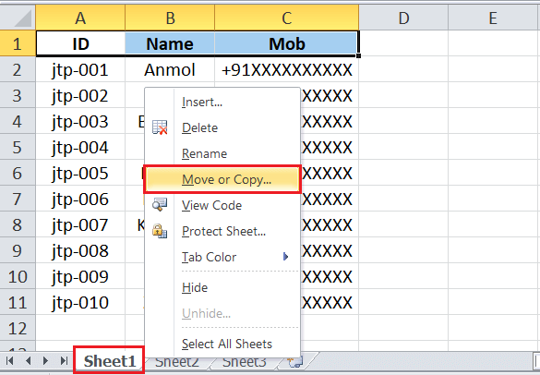

After that, Excel will display a Move and Copy dialogue box, where we need to select the desired preferences. For instance, we can choose where to place or copy the sheet contents under the **'Before sheet'** option. If we want to place a sheet's content to the right of the last worksheet (or to a new sheet), we can click the 'Move to End' option from the list.

Lastly, we can click the checkbox next to the **'Create a copy'** option to duplicate the content without deleting the original content. If we don't select the checkbox, then the original content from the selected sheet will be deleted or moved to the desired location. The copied sheet will keep the title, version number, and other details from the source content.

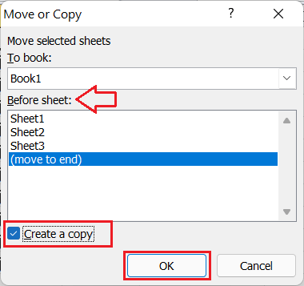

In this way, we can create a copy of the desired sheet or move the content into another sheet. Excel also allows us to copy the sheet content to an entirely different workbook. For this, we must select another workbook (should be open already) from the drop-down list under the **'To book'** option.

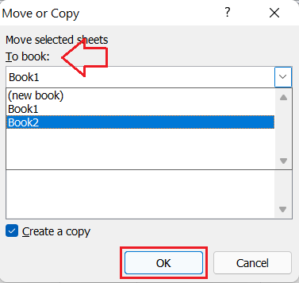

Sometimes, we may need to move any specific sheet across the sheet tabs to rearrange the workbook. Excel allows us to do this using the mouse. To move a sheet, we must first select the specific sheet, click and hold it until we see a small black arrow across the sheet tab.

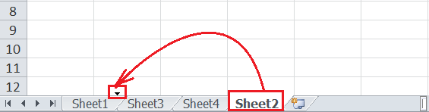

We can place our cursor to the desired location over the sheet tab and release the mouse button to drop the selected sheet.

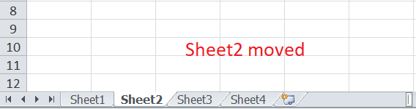

### View Code

We can launch VB (Visual Basic) Editor by going to any sheet tab, right-clicking ad choosing the option 'View Code'. However, this option is rarely used to launch VB Editor.

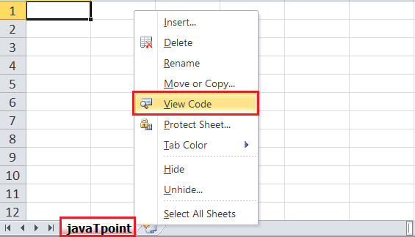

If we launch VB Editor using the 'View Code' option on any sheet tab, Excel will open a code window for that specific sheet. Therefore, this option to launch VB Editor is mainly useful when writing code that will work only for a particular sheet. For example, creating worksheet events.